Onion Detection System Technical Documentation

1. Introduction
The Onion Detection System is a computer vision-based application designed to detect and classify onions based on their colour. The system is built using Python programming language and utilizes a camera for real-time onion detection. The primary goal of the system is to accurately detect whether a given onion is red, pink, or white within 1 second.
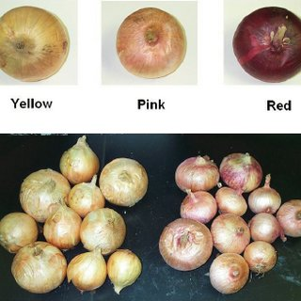

2. Requirements Analysis
Functional Requirements
Capture images of 1kg onions in real-time using a camera.
Detect onions in the captured images.
Classify detected onions into red, pink, or white categories.
Perform detection and classification within 1 second.
Non-functional Requirements
Real-time processing of images with minimal latency.
High accuracy in onion detection and classification.
Support for various camera resolutions and lighting conditions.

3. System Architecture
The system architecture consists of the following components:
Camera: Captures real-time images of 1kg onions.
Image Processing Module: Pre-processes images and detects onions using computer vision algorithms.
Colour Classification Module: Classifies detected onions into red, pink, or white categories.
User Interface (Optional): Displays the classification results to the user.

4. Technologies Used
Programming Language: Python
Libraries and Frameworks: OpenCV for image processing
Hardware: Camera (webcam or Raspberry Pi camera module)

5. Implementation Details
Data Collection
- Collect a dataset of onion images with labels for red, pink, and white onions.
Image Processing
- Pre-process images by resizing, cropping, and normalizing.
- Utilize OpenCV for onion detection using techniques like edge detection and contour analysis.
Colour Classification
- Extract colour features from detected onions.
- Train a machine learning model (e.g., SVM or neural network) using the collected dataset to classify onions into red, pink, or white categories.

6. System Integration
- Integrate the camera with the image processing and classification modules.
- Implement communication between different modules for seamless operation.

7. Testing and Evaluation
- Perform unit testing for individual components.
- Conduct integration testing to ensure the proper functioning of the entire system.
- Evaluate the accuracy and speed of onion detection and classification, ensuring that the system meets the requirement of performing detection within 1 second.

8. Future Enhancements
- Implement optimizations to improve detection speed and accuracy.
- Extend the system to support additional onion varieties or features.
- Integrate with a user interface for displaying classification results.

9. Conclusion
The Onion Detection System provides a reliable solution for accurately detecting and classifying onions based on their colour within 1 second. By leveraging computer vision and machine learning techniques, the system can assist in various applications, including agriculture and food processing.

10. References
OpenCV Documentation: https://opencv.org/
Python Documentation: https://www.python.org/

